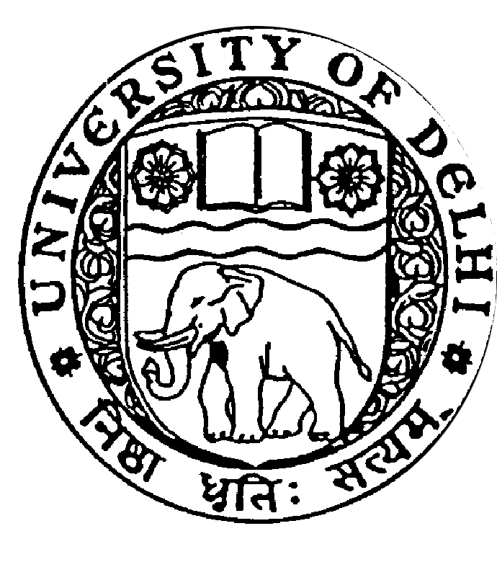
CURRICULUM VITAE
Title | Prof. Dr. | First Name |  | Vipul | Last Name | Singh
Designation |  | Professor |  |  |  |  | 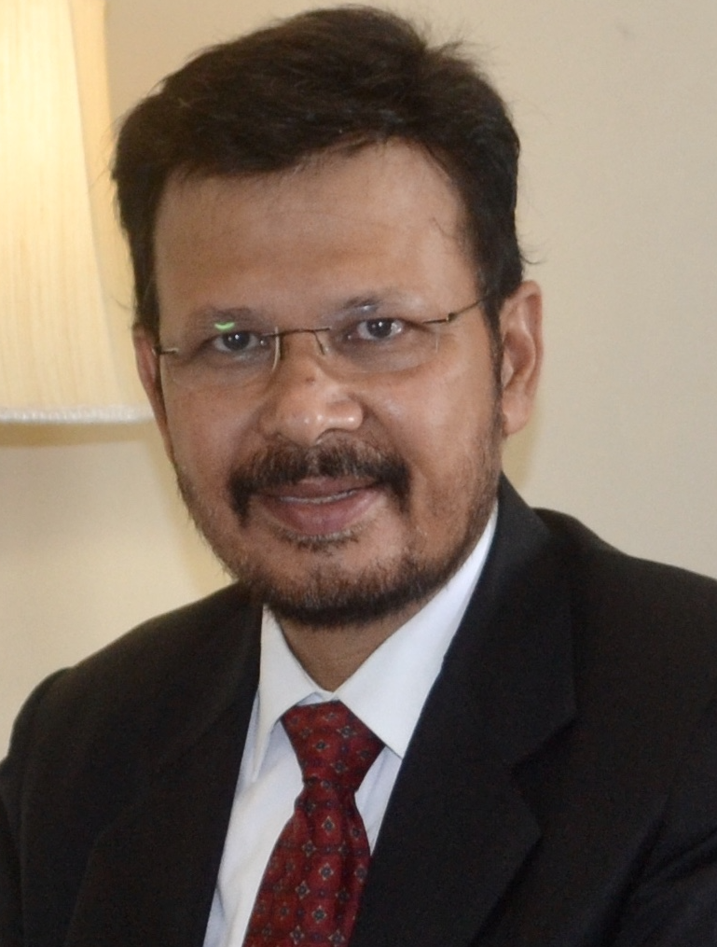
Address |  | Department of History, Faculty of Social Sciences  University of Delhi, Delhi 110007. India
Phone No Office |  | +91-11-27666659
Residence
Mobile
Email |  | vipulsingh.history@gmail.com
Web-Page |  | http://history.du.ac.in/prof-vipul-singh/
Educational Qualifications
Degree |  |  | Institution
Post-Doctoral Fellowship |  |  | Rachel Carson Center, Ludwig Maximilian Universität, München, Germany
Ph.D. |  |  | Department of History, University of Delhi
M.Phil. |  |  | Department of History, University of Delhi
MA |  |  | Department of History, University of Delhi
BA Hons. History |  |  | Ramjas College, University of Delhi
Areas of Interest / Specialization
Specialize in Medieval and Early Modern period of history, and Environmental history; Main area of research includes arid-zone ecology, river ecology, migration, and land-use cropping pattern change in Western Rajasthan, Bihar and Eastern India, Indian Ocean.
Subjects Taught
PhD
Advance Research Methodology: Course Work for PhD students
MPhil
Course II (Part), Vernacular literature: Kanhadade Prabandha, Padmanabha's epic account of Kanhadade; Malik Muhammad Jaisi’s Padmavat.
MA
Global Environmental History, 1500-2000
History of Eastern India, 13th to 18th Century
Conservation, Science and Technology, 1800-2000
Social and Economic History of India, C.1200-1750 AD
The Soviet Union, 1917-1991
Research Guidance

Supervision of Post-Doctoral and Doctoral Thesis
- “Physicians, Botanists as Naturalists : Historicising Colonial Expansion in Natural Landscapes in 19th Century Indian Subcontinent”
- “The Making of Upper Ganga Canal: Study of Society and Economy in 19th Century Western Uttar Pradesh”
- “Education, Marginalised Communities and Political Consciousness in Bihar : 1912-1942”
- “Humour, Paintings and Folklore: Understanding Social Relations in Medieval Mithila”
- “Communication Network in Kumaon and Garhwal, 1850s-1910s”
- “Cantonment and the Urban Space: The Making of Delhi Cantonment 1910 - 1950”
- “Paryavaran Sanrakshan ke Sandarbh mein Baudh Dharm ke Yogdan ka Sameekshatmak Adhyayayan” (Completed)
- “Bundelkhand ki Asmita: Satrahvin evam Atharahvin Shatabdi ke Rajneetik evam Samajik Sandarbh”
- “Bundelkhand mein Sufi Mat ka Prasar evam Dargah ke Anuyayion ka Jatiya evam Samajshashtriya adhyayan” (Post-Doctoral research supervision).
- “Trans-Himalayan Trade, Trade Routes and Pastoral Communities of Kinnaur, 1600s to 1900s”
Supervision of M.Phil dissertation, under progress
- “Making a Legible Space: Ecology, Economy and Colonial Urbanism in Purnia,1765- 1850”
- “Changing Landscape in Nineteenth Century Wayanad: A Study of Coffee and Tea Plantations”
Supervision of awarded M.Phil dissertations
- “Sone Canal and the Remaking of Agrarian Society of South Bihar, 1850s-1900s”
- “Built Environment of Delhi: Land Acquisition, Water Supply and Sanitation, 1911-1931”
- “The Chos of Hoshiarpur: Calamity, Agriculture and ‘Conservationism’, 1852-1946”
- “Famines in Marwar During 19th Century: A Socio-economic Study” M.Phil thesis awarded
Supervision of awarded PhD
- “Inland Fisheries in Colonial Bengal: A Study of Law and Economy”
- “Trans-Himalayan Trade, Trade Routes and Pastoral Communities of Kinnaur (1600s-1900s)”
Publications Profile

Books
- 2018. Speaking Rivers: Environmental History of a Mid-Ganga Flood Country, 1540-1885, Delhi: Primus Books.
- 2014. Paryavaran Par Manav Padchinha: Paryavaran Parivartan ke Aitihasik Sandarbh, Delhi: Trinity.
- 2012. The Human Footprint on Environment: Issues in India, Delhi: Macmillan India Ltd.
- 2012. Indian Knowledge Tradition: Module on Environmental Tradition, New Delhi: Central Board of Secondary Education, Government of India.
Research Papers Published in Refereed/Peer Reviewed Journals/ Books
- 2022. “Massacre, Revolt and British Anxiety: Built Environment of Patna, 1763-1900", Juni Khyat,12(1).
- 2021. “Governing Fluvial Commons: Alluvion and Diluvion Regulation and
Decommonisation”, in Prateep Kumar Nayak, ed, Making Commons Dynamic, London
and New York: Routledge.
- 2020. “Water and the Anthropocene”, Current Research Journal of Social
Sciences, 3(1), pp.3-5.
- 2020. “Cyclones, Shipwrecks and Environmental Anxiety: British Rule and Ecological Changes in the Andaman Islands, 1780s to 1900s”, Global Environment: 13/1:166-94. DOI: https://doi.org/10.3197/ge.2020.130106
- 2020. “Understanding Reverse Workers Migration during the Covid-19 Lockdown in India and the Green Revolution”, https://seeingthewoods.org/2020/06/15/understanding-reverse-worker-migration-during-the-covid-19-lockdown-in-india-and-the-green-revolution/
- Forthcoming. “Governing Fluvial Commons in Colonial Bihar: Alluvion and Diluvion Regulation and Decommonisation”. In: Nayak, P. K. (ed). Making Commons Dynamic: Understanding Change Through Commonisation and Decommonisation. Routledge, UK
- 2018. “Intersectorality in the Governance of Inland Fisheries”, Synthesis Paper (multiple authors), Ecology and Society 23(2):17. https://doi.org/10.5751/ES-10076-230217.
- 2017. “Where Many Rivers Meet: River Morphology and Transformation of Pre-Modern River Economy in Mid-Ganga Basin, India”, in Environmental History in the Making, edited by Estelia Vaz, Cristina Joanaz and Lígia M.Costa Pinto, Switzerland: Springer International Publishing.
- 2017. “Modern Acts, Conservation of Fish and Colonial Interest: Inland Fisheries in Mid-Ganga Diara Ecology, India”, in A.M. Song, S.D. Bower, P. Onyango, S.J. Cooke, R. Chuenpagdee (Eds.), Inter-Sectoral Governance of Inland Fisheries, Canada: TBTI Publication Series, St John's, NL.
- 2016. “Ecological Amnesia: Journey of Medieval Off-take Inundation Canals to Anicut Canals”, Abhilekh-Bihar, Vol.7: 142-56, Bihar State Archives, Patna.
- 2015. “Construction of a Regional Identity: Medieval and Early Modern Perception of the Riverine Bihar”. Abhilekh-Bihar, 6: 271-280. Bihar State Archives, Patna.
- 2014. “Gangetic Floods: Landscape Transformation, Embankments, and Clay Brick-Making”. In Asian Environments: Connections Across Borders, Landscapes and Times, edited by Ursula Münster, Shiho Satsuka and Gunnel Cederlöf, 23-28. Munich: Rachel Carson Center.
- 2012. “Environmental Migrants: Migration as Planned Livelihood Among the Rebaris of Western Rajasthan, India”, Global Environment 9: 50-73.
- 2011. “Could Religion Act as a Force for Conservation? Case of a Semi-Arid Zone in India’. In Conservation of Architecture, Urban Areas, Nature and Landscape: Towards a Sustainable Survival of Cultural Landscape. II, edited by Andrew Dolkart, Osama M.Al-Gohari & Samia Rab, 427-438. Amman: CSAAR Press.
- 2007. “Environmental History of India: Prudent Traditions, Changing Land-use and Migration in an Arid Zone”, Social Science Probings. 19 (1): 33-49.
- 2004. “Ecology and Encounters: The Maratha Demands and Its Impact on Land - Use Pattern in the 18th century Marwar (Rajasthan)”. In Resource Conservation and Food Security, edited by Tapeshwar Singh, 648-684. New Delhi: Concept Publishing Company.
- 2000. “Professional Brotherhood and Change in Physical Environment: The Colonial Factors in Administrative History of 18th Century Patna District”, The Geographer, 47 (1): 70-85.
Papers published in Academic Journals other than Refereed/Peer Reviewed Journals / Newspapers
2011. Book review of Convenient Action: Gujarat Response to Challenges of Climate Change, Eternal India (Journal). 2 (3).
2011. “State Control Over Water Resources: Recent Trends in India”, Deeksha. 8(2).
2009. “Food Crisis: Biofuel is not to Blame”, Deeksha. 6(1): 13-16.
2008. “Jaiv Indhan Nahin Neetiyaan hain Doshi”, Dainik Bhaskar, 9th May.
2008. “Iss Sankat Ke liye Kaun hai Doshi”, Dainik Bhaskar, 6th June.
Conference Organization/ Presentations

Conference Papers and Invited Lectures
- 2022. “The Road to Indian Ocean Empire: Survey, Science and Metreology”, Workshop organised by Deutsches Schiffahrts Museum, Leibniz Institute for Maritime History, Bremerhaven, Germany, on Research Expeditions to India and the Indian Ocean in Early Modern and Modern Times, 3 November.
- 2022. “A River Flooding in my Heart”, Seminar, Department of History, University of Delhi. https://youtu.be/eJiP6LOHiak
- 2022. “'Environmental History of Natural Events”, Webinar organised by Satyawati College, University of Delhi, 26 February. https://youtu.be/M-X8UspqkU4
- 2022. “Understanding Ecological Imperialism and Disease Exchanges”, Webinar organized by Dayal Singh College, University of Delhi, 19 February.

2022. “Yamuna’s Environmental Imprint in History” https://youtu.be/51M29f-roHs

2021. “Anthropocene, Ecological Imperialism & Columbian Exchange: Concepts of Environmental History”. https://youtu.be/rhvFoIDTgEI

2021. “Understanding History of Epidemics”. https://youtu.be/f8MYjmaOZz0
- 2021. “Age of Global Climate Anomaly and the Mughal Rule”, National Webinar organized by Delhi College of Arts and Commerce, University of Delhi, 23 April. https://youtu.be/XBcDlwuS8_s
- 2020. “Historicizing Global Epidemics and the Vulnerability of the Weak”, National Webinar / conference organised by Sophia College, Ajmer on Lessons from the Past: Studying Trends and Response to Epidemics, 10 July.
- 2020. “Epidemics, Exchanges and Hunger”, National Webinar / conference
organised by Shyamlal College, University of Delhi on Diseases, Epidemics and Pandemics in Indian History: Lessons for Present, 20 May.
- 2020. Workshop paper “Climate Change and Society: Recent Historical Methodologies”, in National Workshop on Climate Change, Department of Political Science, University of Delhi, 24 Feb.
- 2019. Workshop paper “Flag-Post in the Indian Ocean: Peopling of the Andaman Islands; 1780’s to 1900’s”, in the Workshop Migrations, Crossings, Unintended Destinations: Ecological Transfers across the Indian Ocean 1850-1920 at Rachel Carson Center, Munich (Germany)
- 2018. Workshop paper “Flood, Avulsion and Governance: The Ganga River in the Nineteenth Century”, John Hope Franklin Center at Duke University, Duke University, Durham.
- 2017. Inaugural address titled “Eco-historic Heritage and Watershed in Environmental History” in National Workshop on Networking on Eco-historic and Cultural Heritage of India at Lady Doak College, Madurai.
- 2015. Paper presentation titled “River, Technology and Rule: Anatomy of Medieval and Modern Canal Construction in the Ganga Basin, India”, at Third Conference of East Asian Environmental History, Kagawa University, Takamatsu, Japan.
- 2015. Workshop on Historical Geographic Information Systems (HGIS) methods, Munich, Germany.
- 2014. Paper presentation titled “River Morphology, Colonialism and Society in Mid-Gangetic Basin, South Asia”, at the World Congress of Environmental History in Guimarães, Portugal.
- 2012. Research paper titled “Landscape Transformation in Gangetic Basin: Land-use Change and Emergence of Clay Brick Making (1850s-2000s)” in Inter-disciplinary Workshop Asian Environments: Governing nature, Negotiating Knowledge, Constructing Subjectivities, Rachel Carson Center, LMU, Munich, Germany.
- 2012. “Environmental Conservation, Development and Indian Tradition”, paper presented at National Conference on Environmental Management at Government College, Bhopal.
- 2011. “Environmental Migrants: Migration Pattern and Everyday Forms of Resistance of a Pastoral Community in Rajasthan, India”. Discussion paper. Rachel Carson Center, LMU, Munich, Germany.
- 2011. Invited to present paper in the Conference on Conservation of Architecture, Urban Areas, Nature and Landscape: Towards a Sustainable Survival of Cultural Landscape, Amman (Jordan).
- 2011. “Higher Education, Indian Tradition and Environmental Concerns”, paper presented at Annual Conference on Higher Education, Mumbai University, Mumbai.
- 2010. “Local Drivers of Land-Use Chang: Study of an Arid Region in Pre-Colonial India” (Unpublished). Paper presented at Hawaii International Conference on Social Sciences, Honolulu, Hawaii, USA.
- 2006. “Subject to Famine: Resource Exploitation and Community Response in 18th-19th Century Marwar, (Rajasthan, India)”, Paper presented at Brisbane Conference 2006, Queensland University of Technology, Brisbane, Australia.
- 2003. “Traditional Method of Land – Use and Water Management in Medieval Western Rajasthan”, paper presented at XXV Indian Geography Congress, Ghaziabad.
- 2002. “Changing Patterns of Land-Use in 18th century Marwar (Rajasthan)”, Paper presented at Commonwealth Geographical Bureau Food Security Workshop International Symposium on Land Degradation: New Trends Towards Sustainable Agriculture, Ghaziabad.
- 2001. “18th Century Rajasthan: Ecology, State Power and Land Degradation”, paper presented at the 61st session of Indian History Congress, Kolkata.
- Participated in Academic Congress at University of Delhi (2012)
- Organised National Seminar “Ethics in Indian Society” at Motilal Nehru College and published a Souvenir with the same title (2009)
- Organised a Symposium “Exploring Delhi” at Motilal Nehru College, University of Delhi and published a Souvenir titled “Exploring Delhi” (2006)
Research Projects (Major Grants/Research Collaboration)

Research Projects
- 2021. Faculty Research Program (FRP) Grant, Institute of Eminence, University of Delhi.
- 2016-2020. Project partner in Simone Müller (PI) DFG Emmy-Noether Research Group “Hazardous Travels. Ghost Acres and the Global Waste Economy”, Rachel Carson Center, Munich (Germany)
- 2015-16. University of Delhi, Research and Development Grant, “Local Sources for the Study of Riverine Plain: The Shahabad Records”
- 2013-14. Mentor of the Innovation project, University of Delhi, “Visualizing Economic and Political Impact of Globalization on Gaddi tribe of Chamba District in Himachal Pradesh”
- 2013-15. Major Research Project (UGC) “Flood Control in the Ganges Basin: Land-Use Change and Social Disparity (1811-1947)”, 2013-15.
- 2013. Fellowship at Ludwig Maximilian Universität, München (May to August 2013), Germany.
- 2012. University of Delhi Innovation Project, “Minining in NCR Delhi: A Socio-economic and Environmental Study”.
- 2010. University Grants Commission (UGC) awarded Minor Research Project titled as “State, Environment and Marginalised Groups: Patronage, Resistance and Adaptation in Pre-Colonial Marwar”.
Workshops
- 2012. Asian Environment Workshop, Rachel Carson Centre, Munich, Germany.
- 2015. Modeling for Environmental Humanities at Research Institute for Mathematical Sciences, Kyoto University, Kyoto.
- 2015. GIS in History, LMU, Munich.
- 2016 and 2017. Co-organiser of Research Scholars’ Workshop in Department of History, University of Delhi.
Awards and Distinctions

- Carson Fellowship at Rachel Carson Center for Environment and Society, Munich, 2013 and 2015.
- ICCR Chair of Indian Studies at University of West Indies, Port of Spain in 2016 (Did not avail).
- ICCR Chair of Contemporary Indian Studies/Humanities & Social Sciences at University of Ho Chi Minh, Vietnam 2014-15 (Did not avail).
- Best Teacher Award 2012 for College Lecturers, given by Chief Minister of Delhi on behalf of Government of NCT Delhi, Delhi.
- Foreign Travel Grant from University Grants Commission in 2006 and 2010.
- Foreign Travel Grant form Indian Council of Social Science Research in 2006.
- Foreign Travel Grant from Indian Council of Historical Research in 2011.
- Foreign Travel Grant from University of Delhi in 2014.
- Certificate of Appreciation for academic excellence by Governing Body of College in 2006.
Association with Professional Bodies

- Editorial Board Member, Water History. Journal published by Springer International.
- Member, Association for East Asian Environmental History (EAEH).
- Reviewed research articles for Journals - Water History, Pastoralism, Journal of Social Sciences etc.
- Evaluated a research monograph “History of Food in Northeast India: Mizoram since Pre-colonial Times” of Indian Institute of Advance Studies, Shimla.
- Evaluated a PhD thesis in History of Gautam Buddha University, Greater Noida (2017).
- Evaluated a DLit thesis in History of Barkatullah University, Bhopal (2014).
- Evaluation Expert for up-gradation from JRF to SRF in Department of History and Culture, Jamia Millia Islamia, New Delhi (2014).
- Evaluation and Expert of MPhil thesis “Textile Workers during Mughal period in Seventeenth Century”, submitted in Department of History and Culture, Jamia Millia Islamia, New Delhi.
- 2013. Member of Committee of Courses, CBSE, New Delhi.
- 2012. Co-convener by CBSE of a newly developed course on “Indian Knowledge and Tradition” to be introduced as Optional Paper for Classes 11 and 12 from 2012.
- 2012. Member of the Curriculum Development committee of History and Social Sciences at National Institute of Open Schooling (NIOS), Ministry of HRD, Government of India.
- Expert member of Selection Committee to appoint teachers in Kendriya Vidyalaya Sangathan, New Delhi (2009).
- Expert member of Selection Committee to appoint teachers in Kendriya Vidyalaya Sangathan, New Delhi (2008).
- Expert lecture in Capacity Building Workshop of NIOS, Ministry of HRD, Government of India (2010).
- ILLL-Microsoft ICT Capacity Building workshop (2009).
- Coordinator, Institute for Life Long Learning (ILLL), University of Delhi for ICT training to teachers of Motilal Nehru College (2009-10).
Invited Lectures / Interviews / Documentary:

Resource Person /Annual Lecture/ Documentaries
- 2022. “Beyond Politics and Economy: Towards a New Approach”. https://podcasts.apple.com/in/podcast/beyond-politics-and-economy-towards-a-new-approach/id1528354651?i=1000489608885
- 2021. “The Mughal Rule and Age of Global Climate Anomaly” https://youtu.be/XBcDlwuS8_s
- 2020. “Global Epidemics: Lessons from the Past and New Discourse on Human-Nature Relationships” https://youtu.be/yW9pe5nwoXQ
- 2020. “Epidemics, Exchanges and Hunger: Lessons from History” https://www.youtube.com/watch?v=LP4IeKmt5Hw&t=290s
- 2020. “बाइसन की कहानी: अमरीकी बाइसन 19वीं सदी में कैसे विलुप्त हो गए थे?”, https://www.youtube.com/watch?v=RC4tgbZj49A&t=2s
- 2020. “Story of Bison: Its near Extinction in 19th Century”, https://www.youtube.com/watch?v=11rmIr8u5t4&t=83s
- 2020. “Story of Indian Vultures: Its near Extiction”, https://www.youtube.com/watch?v=CCg2r9uXuRw&t=11s
- 2020. “गिद्ध क्यों और कैसे विलुप्त हो गए”, https://www.youtube.com/watch?v=W5leQlka29k&t=12s
- 2020. “ग्लोबल वॉर्मिंग/जलवायु परिवर्तन: ग्रीनहाउस गैस उत्सर्जन एवं वैश्विक प्रयास”, https://www.youtube.com/watch?v=r_PI3KqPD3I&t=318s
- 2020. “जलवायु परिवर्तन एवं सत्रहवीं सदी का संकट”, https://www.youtube.com/watch?v=G7RJmYnsfNM&t=141s
- 2020. “1930 के दशक की डस्ट बॉल आपदा: कारण एवं ओकीज प्रवास”, https://www.youtube.com/watch?v=n3Frt6oFI1s&t=856s
- 2019. “History of the City of Delhi”,
https://www.youtube.com/watch?v=tL7JmetsvlI&lc=z22kuxybgl3cfrl0macdp43adfgl2duxmueye3czmuhw03c010c
- 2018. “Flood, Avulsion and Governance: The Ganga River in the Nineteenth Century”, John Hope Franklin Center at Duke University, Duke University, Durham, 16 February https://youtu.be/7djOUJcXt-k
- Colloquium Lecture “Controlling the River: Diara Land and Social Disparity in the Mid-Gangetic Basin", Ludwig Maximilian Universität, Munich on 25 July 2013, https://www.youtube.com/watch?v=cULlwep84tY
- 2017. “Eco-historical Heitage and Watershed in Environmental History”, Inaugural address at Lady Doak College, Madurai.
- 2017. “Environmental Studies in Practice”, at Motilal Nehru College, University of Delhi.
- 2017. “Ecology in Idea and Practice”, at Satyawati College (Evening), University of Delhi.
- 2016. “Vernacular Literatures as Source” at Motilal Nehru College (Evening), University of Delhi.
- 2016. “Conservation of Stepwells” https://www.youtube.com/watch?v=ER_V6hVFqD4&t=17s
- 2015. “Doing Environmental History” at Shyamlal College, University of Delhi.
- 2014.“Anatomy of Delhi Sultanate” at Delhi College of Arts and Commerce, University of Delhi.
- 2014. Resource Person in UGC Orientation Course at CPDHE, University of Delhi.
- 2013. “We Live by the River” River History Interview, https://www.youtube.com/watch?v=3kQu_461CnI
- 2012. Keynote address at National conference organized by Government Arts and Commerce College, Barkatullah University, Bhopal.
- 2012. Chairperson of Technical session of Seminar on “Environmental Management” at Government Arts and Commerce College, Bhopal.
- 2010. Inaugural lecture on “Environment and Development” at Bhagini Nivedita College, University of Delhi
- 2010. “Early Medieval India” at Bhagini Nivedita College, University of Delhi
- 2008. Resource Person at Refresher Course in History, Govt. College, Bahadurgarh.
- Live Lectures on Doordarshan on various topics related to History for undergraduate students. These lectures were telecast Live on DD Vyas-UGC channel. The dates of these lectures are as under:
08.04.2009; 09.04.2009; 25.01.2010; 27.01.2010; 28.01.2010; 29.01.2010; 14.09.2011;15.09.2011, 10.10.12; 11.10.12; 01.08.14; 04.08.14; 05.08.14.
- Documentary “Brick-making in Gangetic Basin”, Part I, https://www.youtube.com/watch?v=FuIRAT4-7rQ
- Documentary “Brick –making in Gangetic Basin, Part II, https://www.youtube.com/watch?v=GJeGTg91qX8
- Documentary “Bemisaal Baolian” on Rajya Sabha TV, https://www.youtube.com/watch?v=Qb8oaKXdleA
- CEC-UGC lecture “Medieval Indian Economy-I”, https://www.youtube.com/watch?v=LYnaYeOunJ4
- CEC-UGC lecture “Medieval Indian History-Delhi Sultanate”, https://www.youtube.com/watch?v=-TWo593BOzk
- CEC-UGC lecture “History: Medieval India”, https://www.youtube.com/watch?v=FBw2O8mFaBI
- CEC-UGC lecture “Economic History of Medieval India”, https://www.youtube.com/watch?v=iEs9Wnql0yo
- CEC-UGC lecture “History: Delhi Sultanate”, https://www.youtube.com/watch?v=mwqx07WyRuM
- “India and Pakistan Face off Over Threat to Water”, Interview to Matt Wade, published in The Sydney Morning Herald (Sydney), http://www.smh.com.au/articles/2008/10/21/1224351253248.html and The Age (Melbourne). http://www.theage.com.au/world/water-row/ (22.10.2008)
Administrative & Academic Assignments
- PhD Coordinator (2022-23)
- Mphil Committee Coordinator (2017-18)
- Coordinator, Research Scholars’ Workshop in Department of History, University of Delhi (2016 and 2017).
- Member, Vice Chancellor’s Empowered Committee (2013).
- Bursar, the Financial Head of the institution (2009-11), Motilal Nehru College for two years term.
- Rapporteur for International Round Table on National Human Rights Institutions organized by the United Nation and National Human Rights Commission, India (2005)
- Convener, Workload Committee.
- Member, Admission committee.
- Member, Sports Committee.
- Member, Fine Arts Committee.
- Member, Debating Society.
- Member, Editorial Board of Water History (Journal) published by Springer, Netherlands

Vipul Singh

